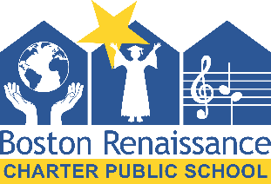
Boston Renaissance Charter Public School
Strategic Planning Meeting

Monday, April 23rd, 2018
10:00am – 12:00pm

1415 Hyde Park Avenue, Boston, MA 02136

Participants:

BRCPS Board of Trustees, BRCPS Leadership Team, ESC Consultant Team
Meeting Goals:
- Have a candid discussion about the strengths and weaknesses of BRCPS, and the opportunities and threats before the school in the coming 3-5 years
- Identifiy 4-5 strategic objectives for the school over the coming 3-5 years, including some level of prioritization of these objectives
- Clarify next steps for the strategic planning process

Agenda:

10:00 – 10:10 Welcome and Introductions – Alexandra Buckmire

10:10 – 11:10 SWOT Analysis Review and Discussion – Franklin Shearer

11:10 – 11:55 Determining Strategic Objectives and Priorities for the Strategic Plan – Franklin Shearer

11:55 – 12:00 Clarify Next Steps and Timeline for Strategic Planning – ESC Consultants

